User’s Guide

Loan Tape’s File Transfer Portal

Contenido
Introduction 3
Previous considerations 3
Login in into the portal 3
Uploading a new file 4
Searching files new file 8
Sign-off the portal 11

Introduction

This document pretends to describe how to use one of the T&O portals to transfer, as a temporary tactical solution, the Loan Tape’s files produced locally in the different geographies to the Inspection Loan Tapes team in corporate area.

Previous considerations

Use of the T&O portal to transfer Loan Tape’s files is a temporary solution to exchange on a secure way the different files produced locally while the definitive solution is developed and deployed.
Once the definitive solution is deployed, geographies will be able to upload and validate automatically the Loan Tape’s files, while being able to access and use the information loaded. This strategical solution is currently being developed and it is expected to be fully deployed for March 2022, just when the first official Loan Tape’s files submission is expected.
On the meanwhile, geographies will be able to test and validate the Loan Tape’s files by submitting the files using the T&O portal and once received, corporate team will be able to execute offline the test and validations and submit back results.
T&O portal allows users to:
- Transfer big files between local teams and corporate teams.
- Ensure transfer is secure and that only required users can access the information contained in the files

Login in into the portal

- Using a web explorer of your choice (it has been successfully tested in Google Chrome, MS Internet Explorer and MS Edge) navigate to the following URL
https://webcdi.aacc.gs.corp/portal/buscador/
Bear in mind that this portal is only accessible using Santander Network by either, accessing in Santander’s premises or using Santander’s VPN network. No one outside Santander’s network can access the portal.

- Once loaded, you should be able to see the following login page.
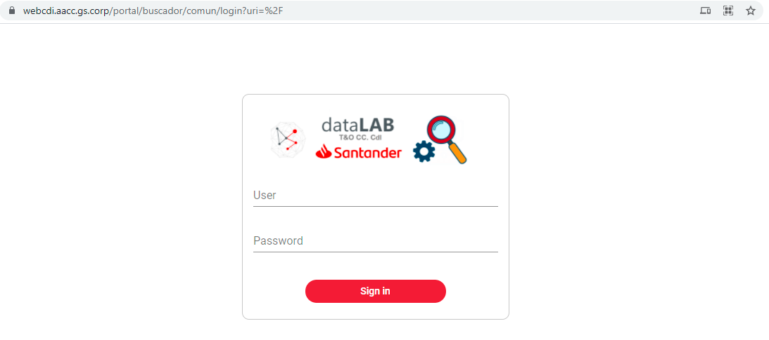
Portal is currently being used in many geographies of Santander group so theoretically you should be able to reach this site. However, if you are not able to reach this Landing Page, then it might be required to set up the network connection (configure proxies, open networks etc). In such case, report to InspectionLoanTapes@gruposantander.com.

- Enter your LDAP’s user and password (the one you usually use to log in to your computer) and click ‘Sign in’.

- If log in was successful, you will see the following Landing Page

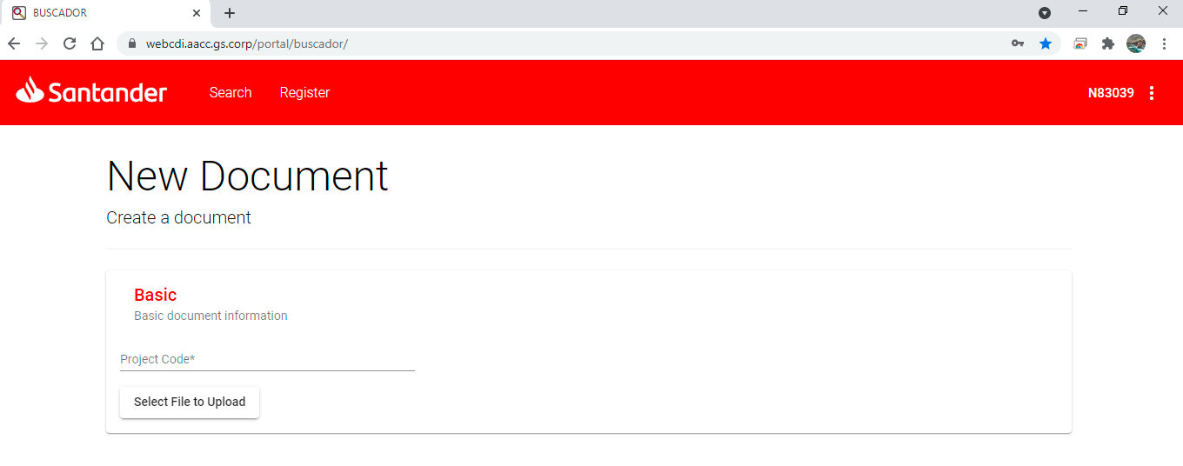

- In case you are not able to login:
  - Make sure you are using your correct credentials
  - If you have never been granted access to the portal, send a request to InspectionLoanTapes@gruposantander.com so proper access can be set up.

Uploading a new file

- You can access the screen to upload a new file either:

  - Right after login, the Landing Page directly allows you to upload a new file.
  - At any moment, by clicking on ‘Register’ link in the upper left side of the portal

- In both cases you will land into following page



- Depending on your user, you might be asked to select the ‘Project Code *’ corresponding to your team. For users only having access to one specific ‘Project Code’, this information might be already populated once you access this screen. Anyway, if this field is empty, just select the right value for your user. For Loan Tape purposes, all the teams have been named as ‘LOTA xxxx’ where xxxx corresponds to one of the Santander’s geographies. Just start typing LOTA in the text box and automatically you will see the possible values.

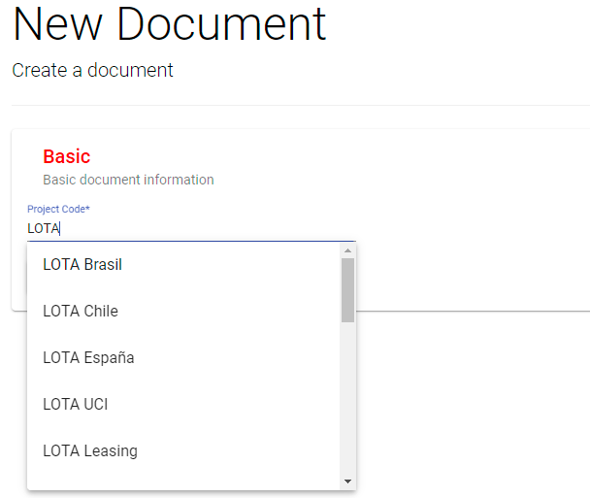

- Click on button ‘Select File to Upload’. This action will open a dialog window to select the file you want to upload.

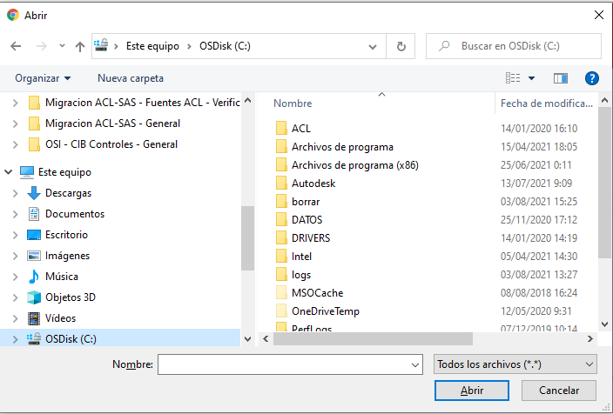

Bear in mind that:
- You can upload any file that you can access with your file explorer.
- You can only upload one file at a time.

- Once selected the file to upload, you will be required to fulfill ‘Basic document information’

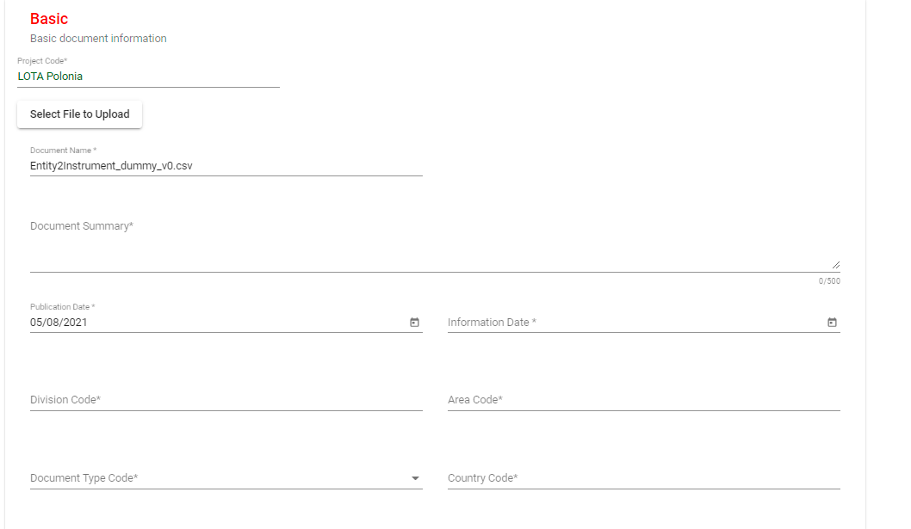
- Document Summary: type a description of the file being loaded. Use this field to specify any comment that you might consider relevant to identify the file.

- Publication date: by default, corresponds to current system date.

- Information date: please use this field to populate the period date corresponding to the files… In general, it should match the ‘Reference Date’ (DT_RFRNC) of the Loan Tape. Ie. 2020-12-31, 2021-03-31, 2021-06-30 etc

- Division Code: please select ‘TECNOLOGIA y OPERACIONES’

- Area Code: please select ‘REGULATORY PROJECT’

- Document Type Code: please select ‘DATOS’

- Country Code: please select the identifier of your country

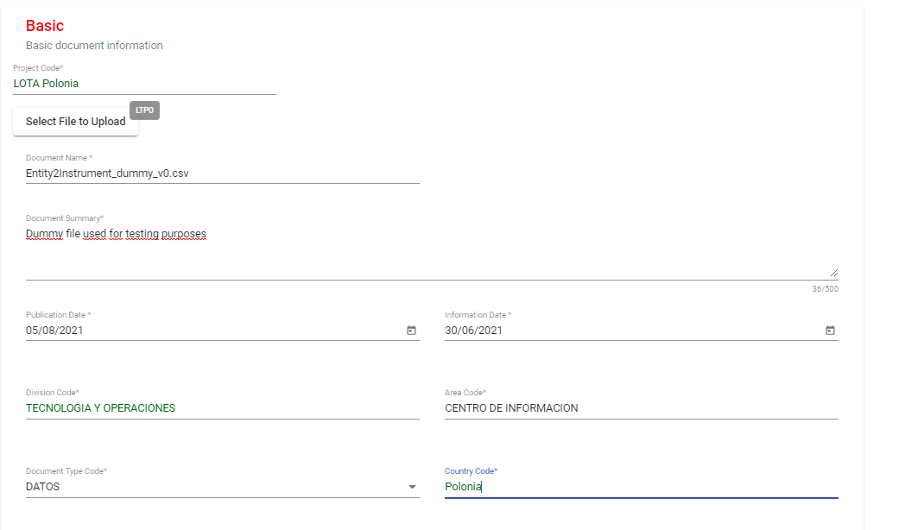
- Select the associated tags for your file. Tags allow you to identify the files being loaded. You can add as many tags as you might consider… however, to correctly identify your Loan Tape files, you are required to add the following tags:

  - LOAN TAPE

  - Select only one of the following tags to identify your file type:

    - ENTITY
    - INSTRUMENT
    - PROTECTION
    - INSTR_ENTITY
    - INSTR_PROTECTION
Once selected you will have 2 tags associated to your file
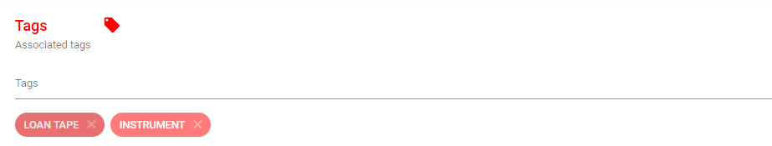

- Contacts information is optional. No need to fill.
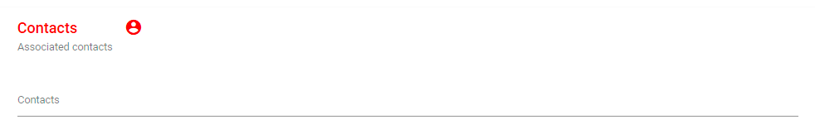
- Once all the required fields have been filled, button to upload the files is enabled and highlighted on the botton left corner.
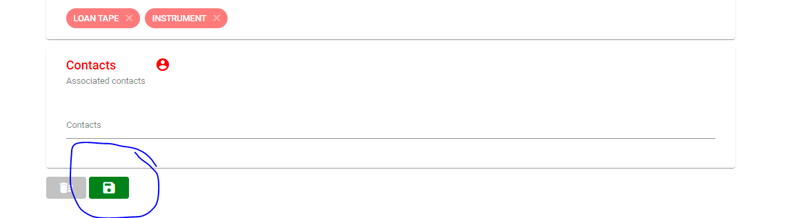
- If you select to upload the file by clicking the ‘Save’ button, uploading will start… you can see upload progress in the same bottom left corner
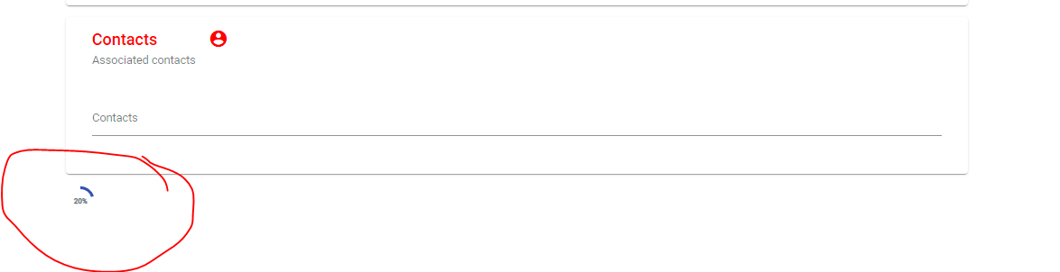
Once completed succesfully, you will see the following message on the bottom of the screen.
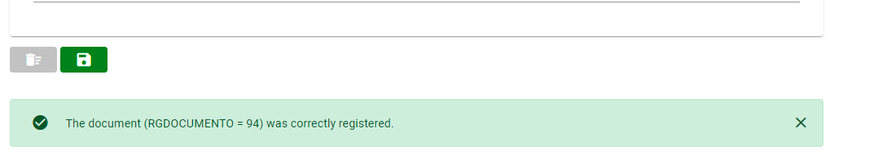

Searching files new file

- By clicking on the ‘Search’ link in the upper bar, you will access the following screen,

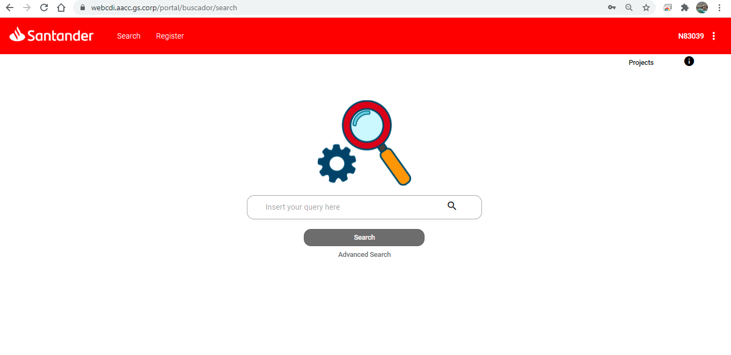

- Type the key words you want to use in your search. It is recommended that you use the tags you used for uploading the file, or any of the words used in the summary. Depending on your query results, you will see something similar to this.

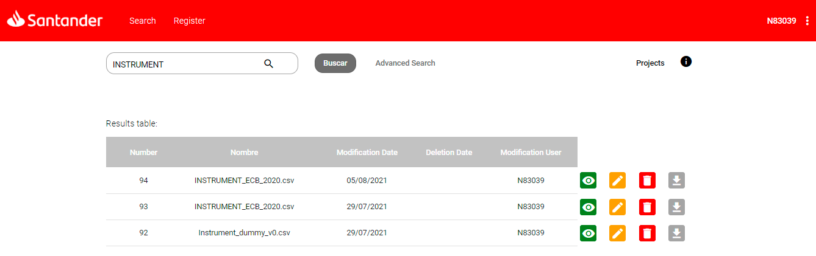

- Depending on your user permissions, you will be able to:

  -  ‘View’ the ‘Basic Document Information.
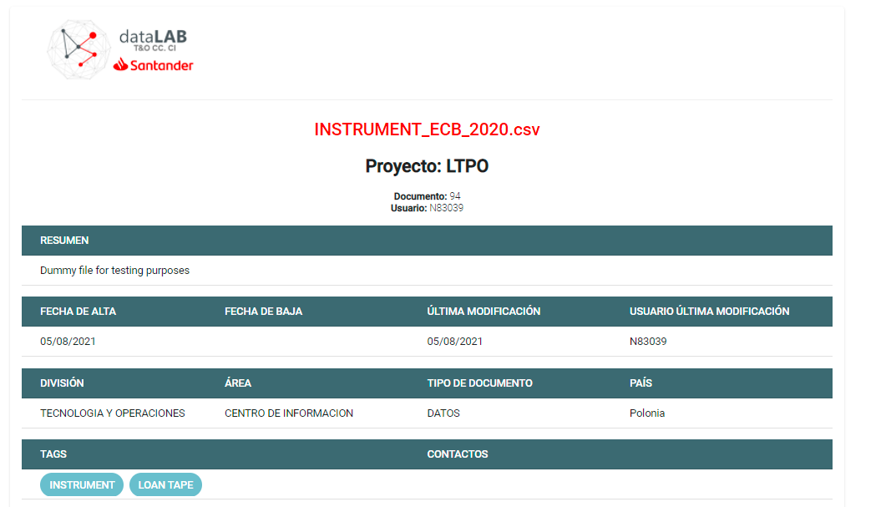

  - ’Modify a document’. You will be redirected to a similar screen that was used to upload the file
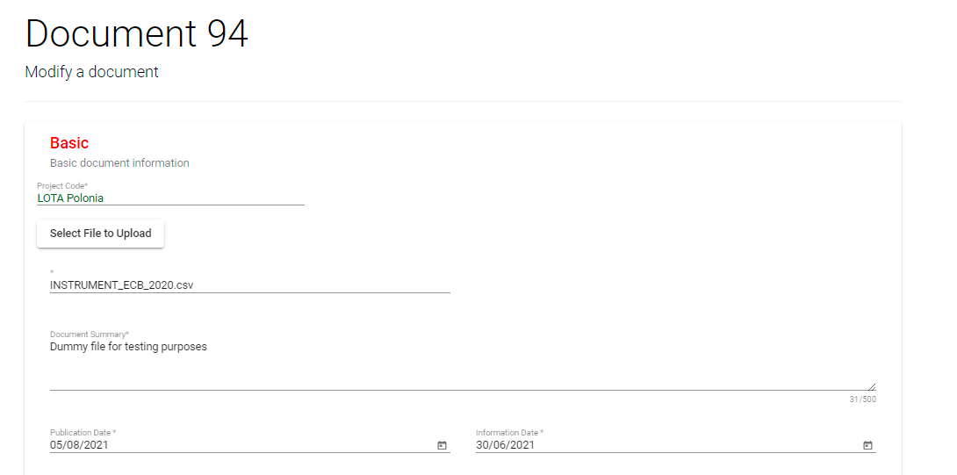

  - ’Delete’ the file. Before deleting, you will be prompted to confirm this action.

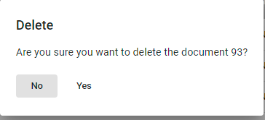

  - ’Download’ the file. It will automatically start downloading the file to your default folder.

- It is important to mention that even you can view the ‘Basic document information’ for every uploaded file into the portal, you will be able only to modify or download the files where you have been granted proper rights. For instance, you can see the following:

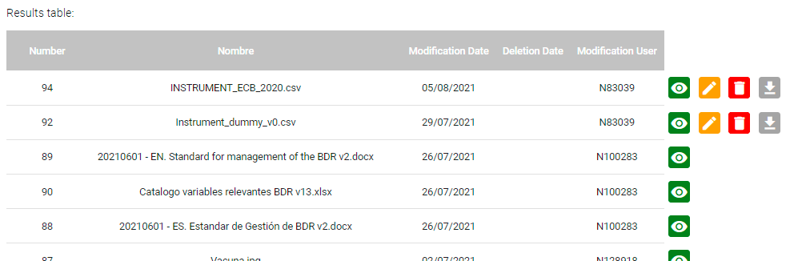

But you can access only files belonging to your group.

Sign-off the portal

User’s can sign off the portal by either:
- [Not Recommended] Closing directly the explorer’s tab. This option is not recommended as session keeps opened while web explorer’s is open.

- Closing directly web explorer’s. This automatically closes the session.

- [Recommended] using the 3 vertical dots in the portal’s right upper corner, you can click and select ‘Sign out’
